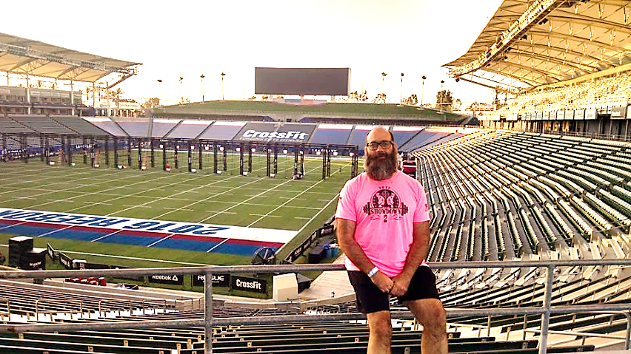
Coach JP is one of TOTF’s most prominent leaders. His certifications include CrossFit Level 1, CrossFit Level 2, USAW Olympic Weightlifting, CrossFit Kettlebell, and CrossFit Defense.
Athlete Spotlight
Coach JP helping set-up at the 2016 CrossFit Games!
WOD Inspiration

You must only be better, stronger and faster than one person: YOURSELF.

DON’T. GIVE. UP. You’re going to be amazing!
Hails & Farewells

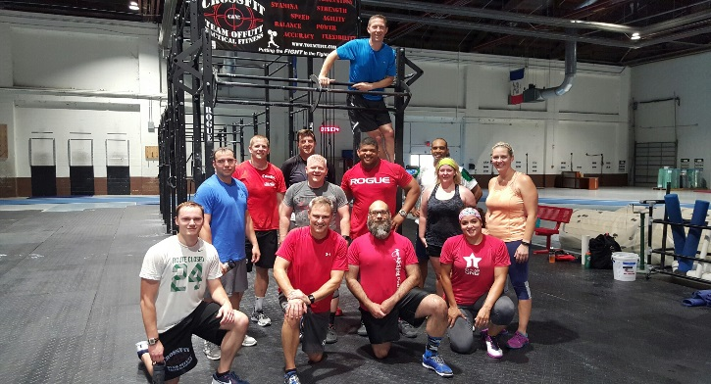
- The next On Ramp class is scheduled for 8 Aug 16 in conjunction with the launching of the Warrior Reborn Program. TOTF’s President, Courtland Holloway, has coordinated with base leaders to give personnel the opportunity to use our program to help them improve/pass their PT test. E-mail totactfit@gmail.com for details.

- TOTF will be hosting Winter Warrior III during the month of January, 2017. TOTF officers have constructed a timeline of events/actions from now through January to ensure this competition goes smoothly for athletes, judges, and volunteers. More info will be provided in subsequent newsletters.

- Did you know you can use our free Web-based log, Beyond the Whiteboard, to record your WODs and track your progress? Send an e-mail to Mike Horner at hornerx5@cox.net to sign up.

Announcements
Recent On Ramp Graduates
Emmie Vroman
Tarry Lawson
Tim Duncan
Beth Clark

Departing Members
Colin Barcus
Chris Daniels
– Many thanks & best wishes to Coach Colin and Coach Chris

